- Master's theorem detailed wali padhni haii.
- DFS BFS ki applications
- Hashing k concepts and formulae
- Recurrence relations in Discrete.
- Generating functions
- Sequential circuit in digital
- TRC, DRC in DBMS
- Decidability and countability
- B and B+ tree deletions
- Minimum average latency (COA)
- Write allocate and no write allocate
- concept of load and store instruction pipelining
- DMA cycle stealing mode k ques
- Deadlock prevention implying ME, progress, BW etc ki theory, check gate applied topic test 3 summary (3 no aaye bhai ).

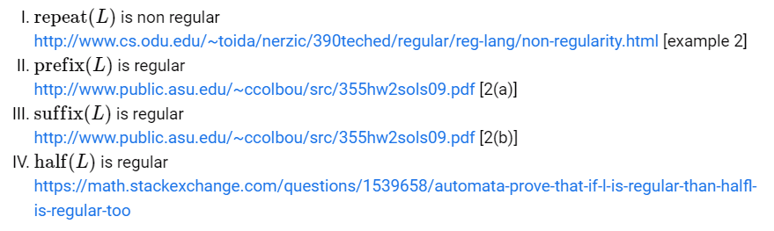

- NFA to DFA conversion me confusion hai !
- PUMPING LEMMA
- Myhill Nerode theorem of TOC (youtube watch later playlist)
- BCD addition subtraction.
- Binary Subtraction using 1’s and 2’s complement.
- Master slave JK flip flop.
- Booth's algorithm (digital)
- IEEE floating point
- PLA, PALb, PROM in digital
- CRC properties. https://www.goclasses.in/s/courses/62e770ae0cf29f3db8f01636/take
- GATE CSE 2015 Set 1 | Question: 1‏9 - GATE Overflow for GATE CSE
Understand the 4th point !!!!!
(205) TCP Misc Part--1 - YouTube
Understand this too : GATE CSE 2015 Set 2 | Question: 34 - GATE Overflow for GATE CSE
- Application layer protocol ki commands.
- Active and passive mode of FTP.
- Full clarity on ER to relational model
- Time stamp ordering and thomas write rule (wound wait, wair and die blah blah)
- Tower of hanoi complete analysis
- Machings, coverings, etc in discrete.
- Practice combinatorics.
- System calls (operating system)
- Quadratic probing (hashing)
- https://gateoverflow.in/43294/gate-cse-2013-question-53
- Algorithm standard question playlist go classes
- Vector space in maths
- Compiler ka runtime videos bache hai
- DBMS transaction management videos bache hai
- https://www.youtube.com/watch?v=Rj1DFLX1XDc&t=2483s compiler

